NADE 2017
Conference Speakers
May 15-18, 2017 New Orleans, Louisiana

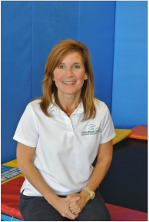 | Sharon Crane, LOTR  Crane Rehab Center, LLC  Sharon Crane, LOTR is a pediatric Occupational Therapist who earned her Bachelor of Science degree in Occupational Therapy at Louisiana State University Health Sciences Center. She has practiced for over thirty years in the Greater New Orleans area in a variety of pediatric settings including hospital, school and early intervention. For the past eighteen years, Sharon has been in private practice providing outpatient clinical services. She and her husband, Mo Crane, a physical therapist are the co-owners of Crane Rehab Center. Sharon is currently the co-chair of the Occupational Therapy Advisory Committee (OTAC) of the Louisiana State Board of Medical Examiners, sits on the Advisory Board for the Occupational Therapy Assistant Program at Delgado Community College and is gratis faculty for the LSU Health Sciences Center, Department of Occupational Therapy. Sharon is certified in Integrated Listening Systems and the administration and interpretation of the Sensory Integration and Praxis Test. She is trained in the Neurodevelopment Treatment approach and is an Interactive Metronome provider. Sharon has provided local and national consultation and training for community-based programs servicing children.  "Handwriting Skills of the School-Aged Child: A Developmental Perspective on the Skills That Support Legibility and Fluency"  This presentation will provide attendees with an overview of the developmental progression of the underlying component skills of handwriting, including fine motor / manipulative skills, pencil skills, and visual motor skills. The presentation will highlight the hand biomechanics and motor control that build legibility and fluency. The presentation will also provide an understanding of how certain developmental and neurological conditions can affect the production and quality of a child's handwriting.
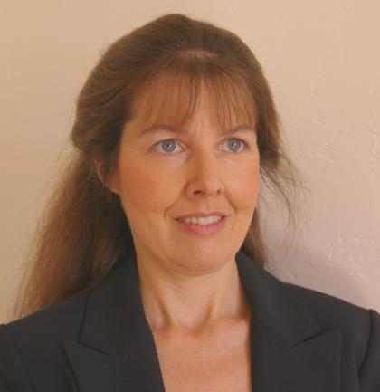 | Heidi Harralson, MA, CDE, D-BFDE  Ms. Heidi Harralson is the managing partner of Spectrum Forensic International, LLC, a full-time handwriting and document examination practice. A court-qualified and board-certified forensic document examiner, Ms. Harralson has lectured extensively on the handwriting sciences to professional organizations and universities, both in the US and abroad. Her published work includes articles based on original research into various aspects of forensic handwriting and document examination that have appeared in peer-reviewed journals. Ms. Harralson has authored two books including Developments in Handwriting and Signature Identification in the Digital Age and Forensic Handwriting Examination of Motor Disorders: Research and Applications. She is the co-author of a chapter on evidential documents in Crime Scene Investigation published by Elsevier/Anderson Publishing.  Over the years, attorneys, as well as public and private clients from around the world, have consulted her firm. A board certified diplomate through the Board of Forensic Document Examiners and the National Association of Document Examiners, Ms. Harralson holds a Bachelor of Science in the behavioral sciences, a Master of Arts in handwriting science and forensic document examination, and a forensic crime scene technician certificate. She also functions as an affiliate professor at East Tennessee State University, teaching courses in forensic document examination. Currently, she is serving as the President of the National Association of Document Examiners.  “Current Trends in Forensic Document Examination Standards and Reporting”  Application of standards and report writing are an integral part of the presentation of forensic evidence. In the U.S., many FDEs rely upon the ASTM or SWGDOC standards in formal report preparation and in court testimony. We will discuss the current use and relevance of ASTM and SWGDOC standards as well as the criticisms these standards have received from publications such as the NAS Report. We will briefly review standards used in Europe and examine the updates from the most recent version of the Forensic Handwriting Method including its recommendations on report preparation (published in Australia in August 2016). Current trends concerning the development of new standards by NIST will also be discussed.  “From Complexity to Transparency in Forensic Science: A Review of the Work and Legacy of Dr. Bryan Found”  Dr. Bryan Found (1962-2016) made a substantial and profound impact on the application of scientific methods and theory in forensic disciplines. His research and collaboration with universities was particularly focused in the pattern-based discipline of forensic handwriting examination. He helped develop complexity theory which sought to bring scientifically reliable boundaries in the examination of signatures. He promoted international proficiency studies and gathered, through LaTrobe University in Australia, thousands of proficiency test opinions whose data was analyzed and published into papers. No other research collaboration has gathered so much data and made such a significant impact on the handwriting sciences. Later in his career, he promoted the use of scientific validation through the application of Bayesian theory and fostered a transparent forensic practice through comprehensive reporting. He helped to contribute to the growing body of literature on the influence of bias in forensic science. He was a scientist and erudite writer, but frequently it was his persuasive oratory skills as an international lecturer and networker that helped to bridge the gap between science and forensic practice. We will provide an educational review of some of his most important contributions including complexity theory, proficiency testing research, forensic reporting, bias, and a modular approach to handwriting examination. Emily Will will be co-presenting this educational tribute.
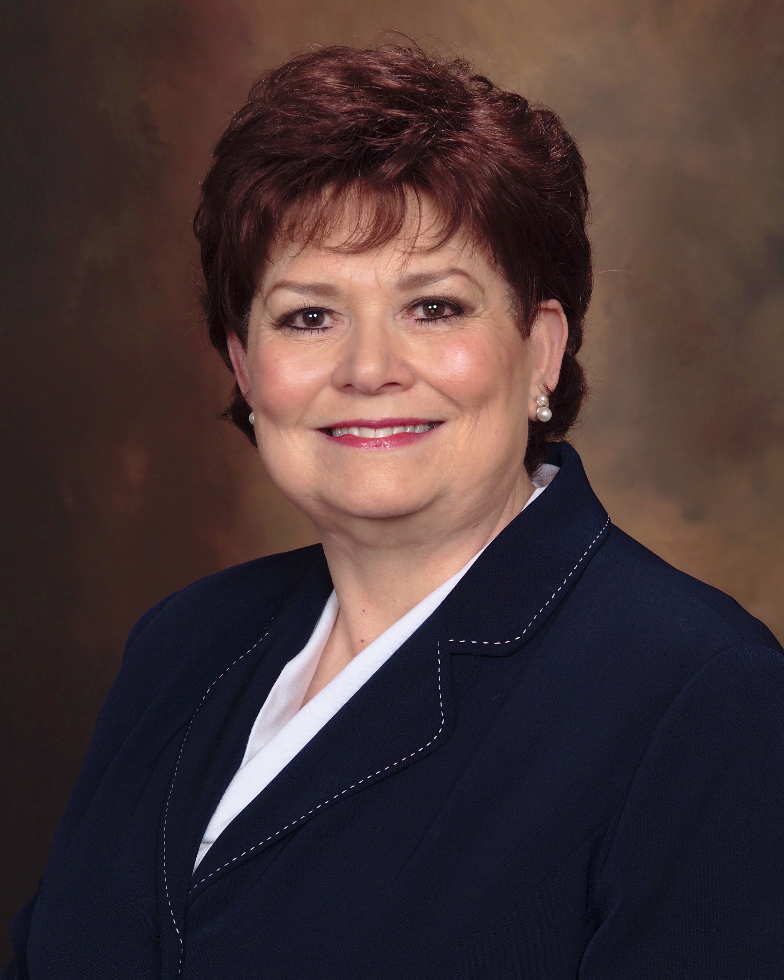 | Linda James  Linda James has owned and operated her own business for 25 years. She is board certified by the National Association of Document Examiner (NADE) and is presently serving as Certification chairperson where she previously served as President and Bylaws chairperson.  Linda is court-qualified and has testified in court and by deposition in numerous cases involving questioned signatures on anonymous notes, forged signatures and contracts, disputed wills, altered typewritten documents, and many other questioned document cases. In her capacity as a forensic document examiner, Linda has testified in Probate, Bankruptcy, State, Federal, Singapore and Alaska courts and for the State Board of Texas. She has also been qualified and met the guidelines under the Daubert/Dupont hearings.  Her professional affiliations are with the Academy of Criminal Justice Sciences, the National Association of Document Examiners, the Fraud Investigator’s Association of Texas, the Association of Forensic Document Examiners, and the International Association for Identification, Texas Division.  “QDE Education & Principles – A Tribute to Barbara Downer”  This class presentation is to celebrate a fellow NADE examiner, Barbara Downer, through exploring her lifetime application of forensic document examination principles. Each attendee will receive a handout of her published articles and CD containing Rare and Out-of-Print QDE books. You won’t want to miss this hour of learning and time of celebration. Also, during the hour, drawings for some special items from Barbara’s library will be held. Co-presenters for this educational tribute include Emily Will and Ginger McKinnon.
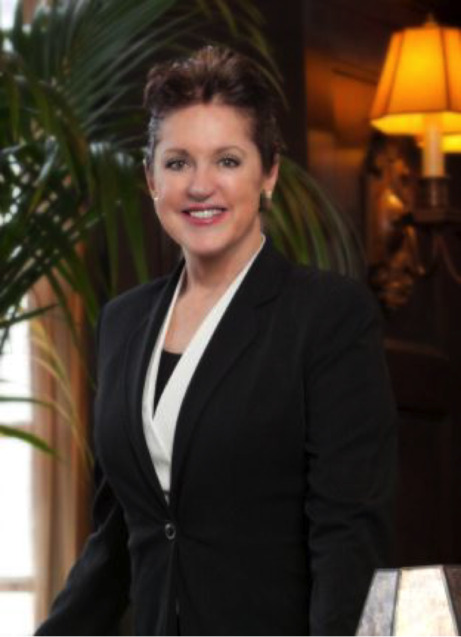 | Jacqueline A. Joseph, CDE, D-BFDE  Ms. Joseph began her forensic practice in 1992, and is the only double-board certified forensic document examiner in the Pacific Northwest.  She is an active board certified member of The National Association of Document Examiners (NADE), and was the chair of the 2016 NADE Continuing Educational Conference, which was held in Portland, Oregon. She is also a board certified member of AFDE, and an active member of ASTM E-30 Forensic Science Committee.  Her published papers include “Identifying the Maker of Handwritten Numbers,” and “Handwriting Forensics: Anonymous note writer identification” and others that may be downloaded from her website.  She has lectured, nationally and internationally, to her forensic colleagues on topics ranging from becoming a more effective rebuttal witness to a new look at post litem motam exemplars. Along with Marcel Matley, she teaches "The Two-pillars of Individuality and Identifiability in Handwriting", as a way to gain a better understanding of the act of writing in order to build and defend a more reliable opinion. It is available for viewing on www.archive.org (Search term: "Jacqueline A. Joseph").  “Practical Tips for Conducting an Observed Forensic Examination”  There will come a time when an FDE must conduct an examination under the close observation of the opposing counsel or his/her representative, and perhaps even the opposition’s expert will be present. Such an examination may be conducted in your laboratory or at the document custodian’s location. The session may or may not be video taped.  The presenter recently completed four cases involving observed examinations. This presentation will share practical tips for a professional and thorough examination when having observers in the room and, perhaps a court order limiting the time for the examination.  Video clips of inadvertent errors made by the expert retained by the opposing side will be provided for your learning experience. Thereafter, the examiner’s performance was used as a rebuttal tactic and the expert was effectively exposed.
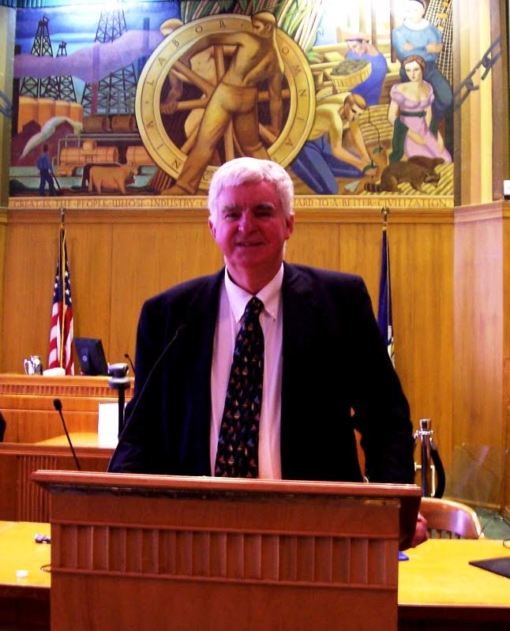 | Louis R. Koerner, Jr.  Attorney at Law  Koerner Law Firm  Louis Koerner has been a licensed attorney for 50 years, with extensive experience in all phases of personal injury, technical, maritime and business litigation. He has tried hundreds of cases throughout Louisiana and across the country, and has appeared before federal and state courts of appeal, the Louisiana Supreme Court, and the Supreme Court of the United States. He is also a member of the Francophone Section of the Louisiana State Bar Association.  “Coffee and Dauberts: How to Walk Away from a Challenge Without a Ding”  The admissibility of expert witness testimony is a critical moment in any federal proceeding. Since the famous Daubert v. Merrell Dow Pharmaceuticals case was rendered in 1993, the standard has changed and a new test has been set forth. An expert witness can have such a strong influence on the trier of fact — jury or judge — that the ability to respond properly to a Daubert challenge can ultimately make the difference between victory and defeat. With 50 years’ experience as an attorney, Mr. Koerner shares tips to help shield any expert witness from being pushed to the sidelines.
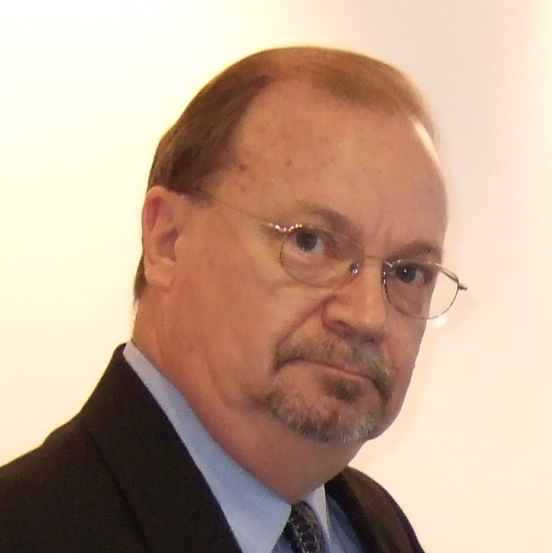 | Jim Lee, Jr., MS, BS  Foster & Freeman USA  Jim Lee has 34 years’ experience as an examiner of questioned documents with the U.S. Army Criminal Investigation Laboratory (USACIL), State of Florida Lottery and in private-practice. He earned his Bachelor of Science (Honors) and Master of Science degrees from Troy State University, Troy, Alabama. He received his training in questioned document examination at USACIL from 1982 to 1984 and retired in 1992 after serving as the Division Chief of the Questioned Document Division, USACIL, Camp Zama, Japan. His rank at retirement was Chief Warrant Officer-4, culminating a career of more than twenty years as a Special Agent with the US Army Criminal Investigation Division Command. He then served ten years at the State of Florida Lottery as a Senior Special Agent and Forensic Document Examiner and Chief of Facilities Security, prior to his retirement in 2002. In 2003, after serving as the Director in the Forensic Services Unit of West Valley Police Department, West Valley City, Utah, he joined the Foster & Freeman USA team as a Technical Sales Applications Engineer. He has also established his own private practice in forensic document examination, Summit Forensic Document Examination Laboratory of Liberty, UT. During this time, he has also successfully completed courses conducted by the U.S. Secret Service, the F.B.I., U.S. Public Safety Institute and Rochester Institute of Technology (R.I.T.) in subjects as diverse as typewriter identification, printing techniques for questioned document examiners and process color for flexography. These qualifications, together with the aforementioned practical experience, have led to him being qualified in the examination of all forms of questioned document examination and comparison, while specializing in handwriting comparative examination.  “Video Spectral Comparator®(VSC) and Electrostatic Detection Apparatus®(ESDA) and other Forensic Document Instrumentation (ESDA) from Foster + Freeman - An Update on Their Use in Forensic Document Examination and Related Research (ESDA®, Best Practices and Miscellaneous Relevant Information”  This presentation is intended to provide the attendee an update to some of the relevant information pertaining to the use of the VSC® and ESDA® and other instruments that can be used in Forensic Document Examination for the examination of questioned documents aided by the use of Infrared, Ultraviolet and transmitted illumination-aided examinations in the VSC® and indented writings and indentations on paper, aided by the ESDA® and also Laser-aided examinations such as those used in RAMAN Spectroscopy and Elemental Composition Comparison. It will include a discussion of research that has been conducted in recent times, regarding the ESDA® and its use. While specifically addressing the Foster + Freeman VSC® and ESDA® in this presentation, the presentation will also address the topic of best practices associated with the use of the ESDA® and other types of Electrostatic Detection Devices (EDD). Attendees to this presentation are encouraged to share any ESDA®/EDD tips that they have discovered in their practice and to share accounts of any interesting or unusual cases that they have encountered where use of the ESDA® or another model of EDD has played a significant or unique role in the discovery of evidence in the case. Additionally, attendees are encouraged to bring their concerns and questions about the use of the ESDA® as well as any questioned document cases with them to the presentation for discussion as time constraints and client confidentiality agreements may allow.
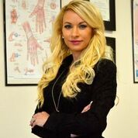 | Krista Madere, LOTR, CHT  Licensed Occupational Therapist, Certified Hand Therapist  After graduating from Louisiana State University in New Orleans in Occupational Therapy, Ms. Madere worked in various in-patient and out-patient settings providing occupational therapy and developing occupational therapy programs. She worked extensively with patients in managing the treatment of adults with orthopaedic and neurological disorders, primarily of the elbow, wrist and hand. Currently as the lead therapist at the main and satellite clinics of The NeuroMedical Center in Baton Rouge, LA, Ms. Madere invented and patented Readi-Steadi®Orthotic Glove System for patients with debilitating hand tremors, including but not limited to the diagnosis of Parkinsons, Essential Tremor, Multiple Sclerosis, Huntingtons, Cerebellar CVA and Dystonia.  “Readi-Steadi® Orthotic Glove System”  At the completion of this presentation attendees will learn about common tremor disorders and current management of them in clinical practice. They will understand the anatomy of overactive muscles commonly observed in patients with tremor disorders. Finally, they will witness a custom fabrication of the Readi-Steadi® Orthotic Glove System and understand how fine motor and hand control is effectively restored as a result of this device.
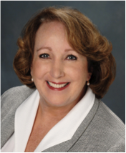 | Ann Mahony, CDE  Board Certified and court qualified, handwriting and forgery expert Ann Mahony has been testifying in the field of questioned documents for over two decades in Federal and Superior courts. Her work includes examining wills and trusts, altered medical and insurance records, anonymous letters and hate mail, real estate and tax matters, passport and customs documents, marriage and birth certificates, and numerous documents for banks and financial institutions. In addition, she assists retail and commercial enterprises with the escalating challenge of internal employee theft. Clients include Bank of America, Federal Express, Coldwell Banker, Chicago Title, State Farm, Kaiser Permanente, Macy’s, Eddie Bauer, Montgomery War, and others, as well as major law firms worldwide.  “Your Exemplars Will Make or Break Your Case”  Were you to ask a surgeon to operate with one hand tied behind his back, you’d be compromising his skill and expertise, not to mention the possible outcome of the surgery. As with any profession, regardless of the skill of the practitioner, when shortcuts are taken or compromises made – in time, tools available, material provided, etc. – the final product will reflect these concessions. Yet now more than ever, document examiners are being provided with scans only, and/or asked to do more with less. Problems that arise from inadequate exemplars include - two or more suspects having similar writing, a suspect writing containing an identifying trait that surfaces intermittently, but is essential for a positive identification, and more. Most distressing may be viewing exhibits from an opposing expert which can selectively slant evidence, leading to a false conclusion. Your exemplars MUST reflect the Range of Variation of the writer. Without adequate material to counter such claims, your opinion and your client suffer the consequences. Ann will present three cases, which could have taken a wrong turn without adequate exemplars. (They include two people with similar writing, as well as refuting exhibits from an opposing expert.)
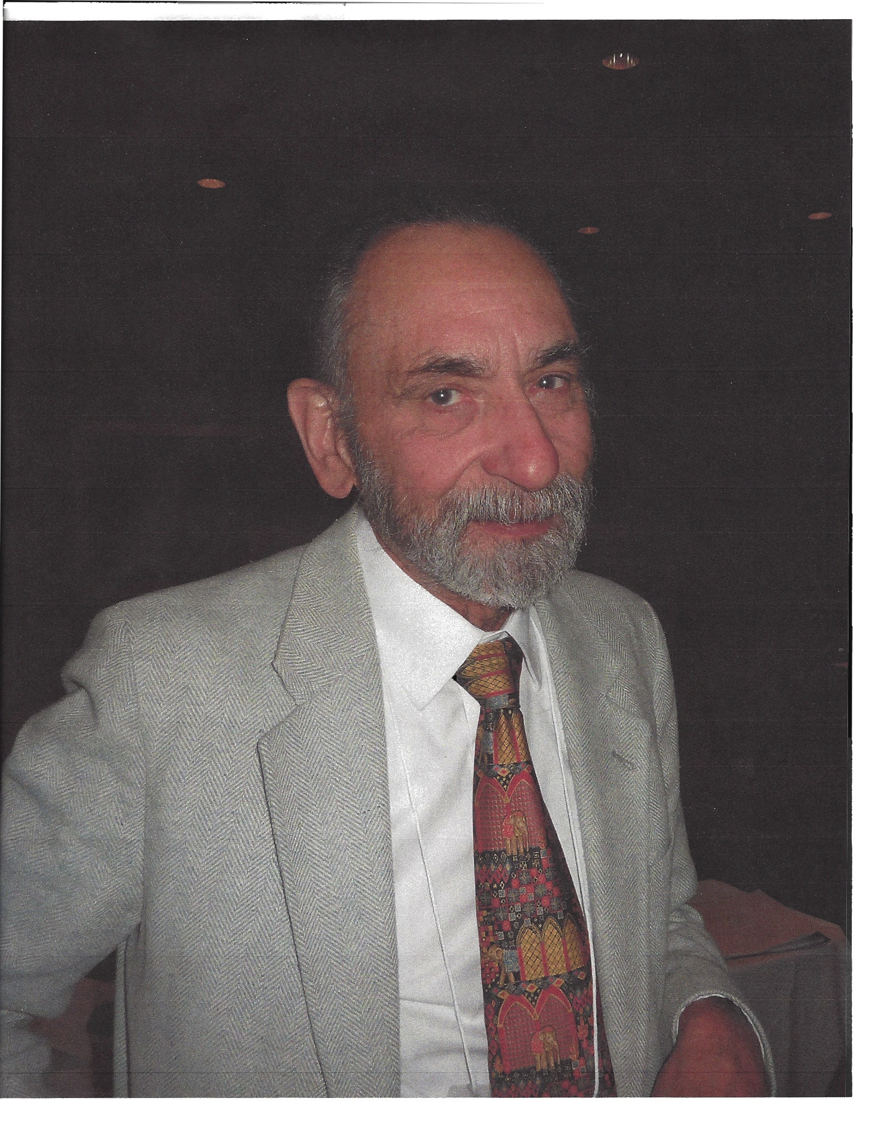 | Marcel Matley  In 1985 Marcel began work formally as a document examiner. He has a Masters of Library Science from Immaculate Heart College, Los Angeles, CA. His continuing studies cover all aspects of document examination and include paleography, penmanship and oriental calligraphy, while he continues research in the medical and legal fields as related to document examination. Marcel has more than 70 professional publications, about half of which are posted open access at https://archive.org. (Search term: "Marcel Matley") His goal is to build up a consulting service to attorneys and document examiners. He is a popular presenter in the field of handwriting and document examination and an active, re-certified member of NADE, having served on various committees.  He and his wife Helen live in San Francisco in a 1908 Victorian, which they are progressively enhancing. If you visit the City, you are welcome to call and arrange a visit. Formally the AHAF Library was housed in their home. When a new librarian took over AHAF Library, it was renamed the Marcel B. Matley Handwriting Research Library. Marcel also has a personal collection of more than 15,000 items related to forensics and handwriting.  “Exposing Illogical Logic and Being Logically Logic”  After a couple illustrations of how modern logicians can lead you terribly astray, we will briefly review several easy-to-understand ways to employ logical logic. The main focus will be on a method that uses a series of simple, commonsense questions to uncover bad logic in an opposing retort of testimony and what to do about it. We will close with the most effective and fun way to expose incorrect opinions by use of disjunctive logic, exploring the power of the much-misunderstood dilemma.
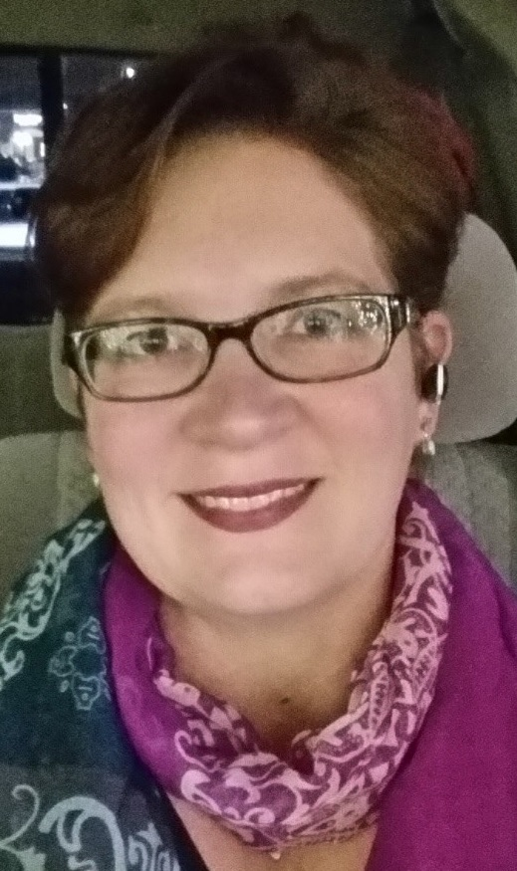 | Ginger McKinnon  My name is Ginger McKinnon. I have been creating court exhibits and other illustration charts since 1995. In 1996 I was trained on several copy machines and software programs for Kinko’s to assist others in creating the perfect document, flyer, announcement, and presentations both large and small. Throughout the years I have worked with various software programs to help illustrate the findings of various cases Linda James has reached and under her direction. I have also created numerous training manuals and other office forms using such software. I have assisted in creating many presentations through PowerPoint. My knowledge is based on 20+ years of working extensive hours with different software programs and evolving my skills as technology changes.  “Creating and Modifying PDF's with Nitro”  During this mini-class, you will be shown how to create a PDF from a word document, combine PDF documents, add Bates numbers and other edits, replace/edit pages within a PDF, and other fun tricks all with Nitro!
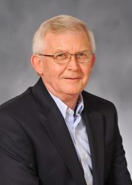  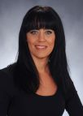 | Larry Miller, Ph.D.  Dr. Larry S. Miller is a Distinguished Professor and Chair of the Department of Criminal Justice & Criminology at East Tennessee State University in Johnson City. He is also Director of the Graduate Program in Forensic Document Examination at ETSU. Dr. Miller has been a forensic document examiner since 1981 and has testified numerous times in Federal and state courts in Tennessee, Virginia, Kentucky and North Carolina. He is board certified with the National Association of Document Examiners. Dr. Miller has authored numerous textbooks and research articles published in refereed journals. His Ph.D. is from the University of Tennessee – Knoxville in Public Safety with collaterals in Forensic Anthropology and Criminology.  Chris Rush, Ph.D.  Dr. Chris Rush is an Assistant Professor in the Criminal Justice & Criminology Department at East Tennessee State University. She received her B.A and M.A in Criminal Justice & Criminology from East Tennessee State University and Ph.D. in Criminal Justice from the University of Arkansas at Little Rock. Her dissertation focused on the effects of residency restrictions on sex offenders and the community, focusing specifically on the city of Little Rock.  Currently, her research interests include sex offender behavior and policies, environmental criminology, forensic document analysis and crime mapping analysis. Dr. Rush serves as a forensic document examiner for the State of Tennessee and works in the Forensic Document Laboratory at ETSU. She has published books and book chapters as well as articles in peer-reviewed journals including Deviant Behavior and Violence & Gender. She has worked with several federal, state and local agencies regarding various criminal justice matters such as program evaluation, prisoner reentry, forensic training, and investigative policies and regulations.  “Reflex of Avoidance in Spatial Restrictions for Signatures and Handwritten Entries”  Within the myriad of disputed documents encountered in the science of forensic document examination, questioned handwriting is the most prevalent. This includes the simulation or alteration of handwriting and signatures. The current study examined the changes that may occur in writing when given a limited amount of space. Several participants completed a survey wherein writing samples were taken under varying space allowances. These space restrictions were made under differing conditions such as boxed signatures, additions to previously written material, and alterations to letters and numbers. The results of the study found characteristics of reflex of avoidance in the participants’ handwriting. These characteristics included changes in height, width, and letter spacing in accordance to the amount of space provided. The examples of reflex of avoidance defined throughout this study may serve to assist forensic document examiners in the detection of alterations within questioned documents.
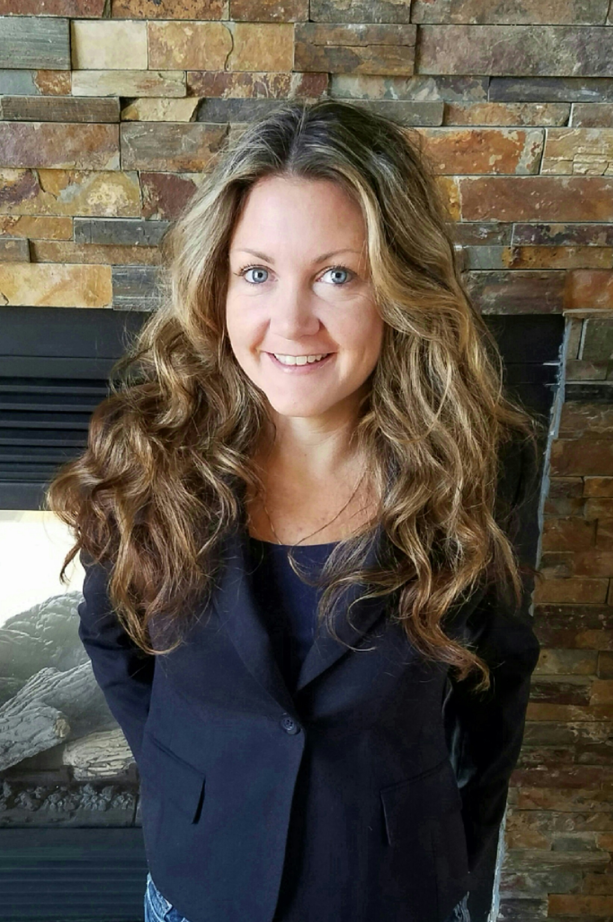 | Sharon Nakich, PMP, BA  OSAC Project Manager  National Institute of Standards and Technology  Sharon Nakich is a project manager at the National Institute of Standards and Technology (NIST), supporting the Organization of Scientific Area Committees for Forensic Science (OSAC) program. The OSAC is composed of 34 operating units populated by over 560 members and over 250 affiliates. It provides the national infrastructure for identifying, generating and adopting technically sound forensic science standards and guidelines for the forensic industry. Sharon received her bachelor’s degree from the University of Maryland, College Park, and has more than 15 years of experience in project management.  “Forensic Science Standards and OSAC—a Recent History”  Standards development in the forensic science industry was previously executed through Scientific Working Groups (SWGs) that focused on specific forensic science disciplines like questioned documents or firearms analysis. These SWGs published their documents on their websites or through a standards developing organization (SDO) and were funded by various components of the United States Department of Justice. During 2014, funding for many of these SWGs was no longer available and OSAC was being developed to further standards development in specific forensic science disciplines. The OSAC is now operational, and has submitted over 25 documents or document concepts to SDOs for the formal development of documentary standards, and is also promoting standards on the OSAC Registry. This briefing will provide details on the status of the OSAC Program, a snapshot of the relevant standards and guidelines in the queue (including from the Forensic Document Examination Subcommittee), and mechanisms on how all stakeholders can participate.

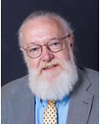 | Tom O’Connor  Senior ESI Consultant  Advanced Discovery  Tom O’Connor is a nationally known consultant, speaker and writer in the area of computerized litigation support systems. He is a New England native who graduated from The Johns Hopkins University in 1972 with a BA in Political Science. After attending law school for one year at The University of Notre Dame, Tom returned to Baltimore and undertook a career as a paralegal specializing in complex litigation.  Tom has worked with virtually every major litigation support software on many cases. He has designed databases and trained legal staffs in private firms, corporate legal departments and public agencies in their use as well as with electronic document depositories and trial presentation systems. Most recently he has been active in electronic discovery efforts, assisting firms and corporate counsel in matters of retention policies, litigation holds and document exchange protocols. He has also been appointed as a technical consultant by various federal and state courts on cases dealing with large amounts of electronic evidence.  “Is Keyword Searching Really Dead?”  This topic covers the history of search technology in the legal professions with a detailed conversation about the traditional workflow models including keyword searching as a means to determine relevance within a dataset. A special focus is the use of newer innovations in analytic technology such as concept searching and clustering that can lead to a much more refined, highly informative and iterative discovery process.
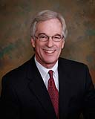 | Glen R. Petersen  Attorney at Law  Hymel Davis & Petersen  A career prosecutor until entering private practice in 2004, Mr. Petersen has distinguished himself in various areas of complex, white-collar crimes, primarily in the health care field. After receiving his undergraduate degree in Business Administration from Louisiana State University, Mr. Petersen earned his law degree from LSU’s Law School in 1977. Following an initial stint in the Criminal Division of the state attorney general’s office, Mr. Petersen joined the staff of the Baton Rouge District Attorney’s Office where he was lead prosecutor in almost 90 felony jury trials during a four year career there. In 1984 Louisiana’s attorney general re-appointed Mr. Petersen as an Assistant Attorney General in the state’s Medicaid Fraud Control Unit. For almost fifteen years Mr. Petersen was lead prosecutor in the prosecution of numerous health care providers who had cheated the state’s Medicaid program.  He was an instructor at the Federal Law Enforcement Training Academy in Glynco, Georgia on the topic of Medicaid Fraud for several years and addressed various advocacy and professional groups within the state and across the country on the topic of health care fraud and patient abuse. During this same time Mr. Petersen was a Special Assistant United States Attorney for both the Middle and Western Districts of Louisiana. In 1998 Mr. Petersen joined the United States Attorney’s Office for the Middle District of Louisiana, continuing his prosecution of health care providers who defraud government programs, including Medicare. He remained with that office until joining his two partners (both former federal prosecutors) in 2004, where he represents health-care providers from the defense side.  “Building a Wall………….Against Fraud”  How do documents signed in the presence of a notary public come to forensic document examiners as questioned? This presentation will help explain the role of a notary public, what procedures should be followed and help explain how notarized documents could later come under examination of the FDE. It will cover:  - Notary Publics and Applicable Laws  - Authority of Notary Publics, Qualifications, Requirements, Legibility, Liability  - “Sworn to and Subscribed Before Me....” and other “trite” terms, such as “Appearing before me on this day....” “Before me personally appeared......” “Subscribed their names in the presence of....”  - Ex Officio Notaries ”Lawyers in Love” Trouble Our Symbiosis (or....why should you know this?)
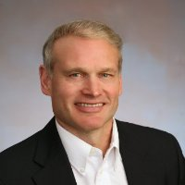 | Tomlinson Rauscher  Vice President, Systems and Software  Topaz Systems Inc.  Dr. Tomlinson Rauscher has 25+ years of experience managing the development and delivery of computer systems products. He worked at Xerox Corporation as Manager of Software Systems Design in the Electronics Division and Manager of the System Products Family Group in the Engineering Systems Division. From 1997 through 2007, Dr. Rauscher held executive engineering management positions in the computer storage industry. Since 2007, he has directed the design and development of electronic signature hardware and software systems at Interlink Electronics and Topaz Systems.  Rauscher earned his B.S. at Yale University, his Ph.D. in Computer Science at the University of Maryland and his M.B.A. at the University of Rochester William E. Simon School of Business. Dr. Rauscher has been a speaker, panelist, session chairman, and program chairman at several technology, computer and management conferences, addressing technology topics such as electronic signature technology, computer storage systems and software development processes, and management topics such as time-to-market and organization architecture. He is the author/co-author of two books, more than 25 technical publications and five patents.  “Electronic Signatures – Capture, Application, and Verification”  With the growing use of electronic signatures and evolving hardware technology, there are now many types of devices that appear capable of capturing electronic signatures. We describe different device types, like signature pads and tablets, and the types of signatures they can collect. We demonstrate how biometric signatures can be applied to documents to sign them in a secure way, so that the attempted modification of signed electronic documents after signing can be detected. We also will illustrate the pitfalls of certain other signature types whereby documents might be modified to fool document examiners. Some court cases will be discussed to provide insight into the legality and utility of electronic signatures. We present software tools to support forensic analysis of electronic signatures by professional document examiners, focusing on signature verification. Armed with this information and these tools, document examiners will have deeper insights into analyzing document and signatures, and can provide guidelines for designing secure signature capture systems.

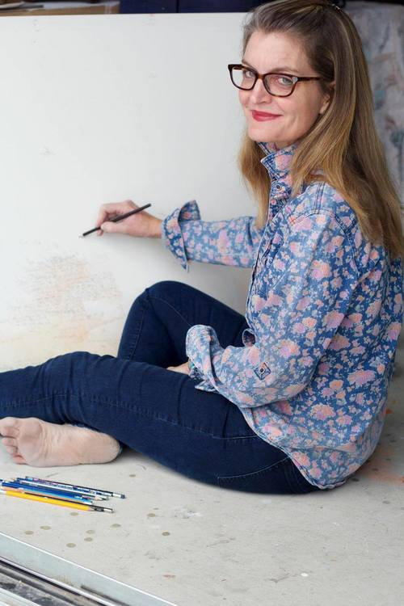 | Karoline Schleh  Assistant Professor of Studio Art  Director of Exhibitions, Collins C. Diboll Gallery  Loyola University, New Orleans  Karoline Schleh is a native of New Orleans, where she lives and works with her family. Karoline's work is included in the collections of the Louisiana State Museum, the New Orleans Museum of Art, the New Orleans Arts Council, and private collections. She has received grants from the Pollock Krasner Foundation, the Joan Mitchell Foundation, and the Louisiana Cultural Economy Foundation. Callan Contemporary represents her in New Orleans, and Ann Connelly Fine Art represents her in Baton Rouge. In addition to her studio work, she works as an Assistant Professor of Studio Art and is the Director of Exhibitions for the Collins C. Diboll Art Gallery at Loyola University, New Orleans.  “Mirror Writing”  Mirror writing is formed by writing in the direction that is the reverse of the natural way for a given language, such that the result is the mirror image of normal writing. In a 20-minute talk with digital presentation, I will discuss why, and how (to the best of my ability), I write in long hand backwards in my work. My interest in handwriting began at a very early age with my German grandmother teaching me a gothic German alphabet from her native village in the Black Forest. This love of writing has evolved into the "flipped script" in my artwork from my training as a printmaker in my mid-twenties. I will discuss this with images, and talk about writing in terms of drawing and observation.
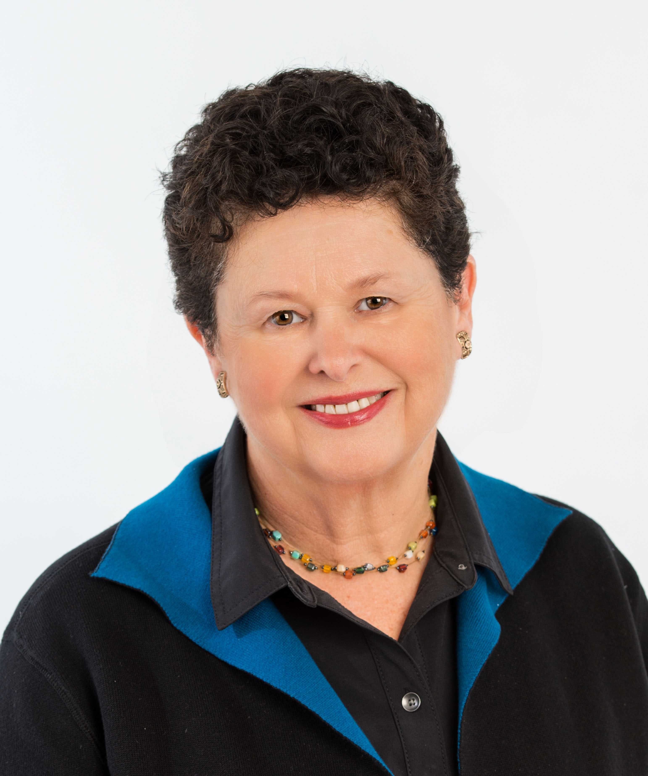 | Patricia Siegel  Patricia Siegel is an executive coach, handwriting analyst, certified forensic document examiner, and president of The American Society of Professional Graphologists. Pat was formerly a faculty member at The New School of Social Research (New School University), where she co-directed an accredited handwriting analysis and identification program. She has testified in Federal, New York and New Jersey courts and is certified as a document examiner by the International Association of Document Examiners and the Scientific Association of Forensic Examiners. Pat is an Associate Member of the National Association of Document Examiners and she is a Diplomate with the American Board of Forensic Examiners. She received a B.S. from Cornell University and an M.A. from New York University. She also has a Professional Coaching Certification from the Zicklin School of Business, Baruch College.  “Use of Measurements in Handwriting Identification: How it May Influence Reliability in the Authentication Process”  In an effort to improve methodology in forensic document examination, experts are looking more seriously at using measurements, quantitative measurements in particular, as part of the examination and discovery process. Demonstrating measurement relationships can also help explain the basis of an opinion during testimony. This presentation will discuss how and when measurements can be significant, or when they are not, in coming to an opinion. It will explore, as well, the advantages of categorizing qualitative graphic elements, such as stroke quality and individuality of letters, to supplement or replace quantitative measurements.
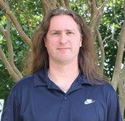 | Arend W. A. Van Gemmert, PhD  Associate Professor, School of Kinesiology  Louisiana State University  Dr. Van Gemmert received his bachelor’s degree in Psychology, and his Masters and PhD degrees in Experimental Psychology from the University of Nijmegen (currently Radboud University), The Netherlands. In 1992, he also was an ERASMUS Student (European Exchange Program) in the Department of Psychology, University of Birmingham, UK, and in 1994 he received a NATO Fellowship (North Atlantic Treaty Organization) to attend the summer workshop on “Multisensory Control of Movement” at the ISAS, Trieste, Italy (International School for Advanced Studies). In 1997 he joined the Motor Control laboratory at Arizona State University (ASU), Tempe, Arizona, USA, directed by Professor George Stelmach. At ASU, he first was a Post-doctoral research Associate (1997 – 1999), then a Faculty Research Associate and in 2005 he got promoted to Associate Professor Research. In 1999 he was appointed as a Special Project Associate in the Department of Neurology at the Mayo Clinic Scottsdale, Arizona as part of the research team of Dr. Charles Adler. Both his appointments at Mayo Clinic and ASU ended when Dr. Van Gemmert joined the faculty of the Department of Kinesiology (currently School of Kinesiology) at Louisiana State University (LSU, August 2008). Immediately after his arrival, he started the LSU Fine Motor Control and Learning laboratory and joined the faculty of the LSU Life Course and Aging Center (LCAC).  Dr. Van Gemmert’s professional memberships include the North American Society for the Psychology of Sport and Physical Activity (NASPSPA), the Society for Neuroscience (SfN), the American Psychological Association (APA), the Psychonomic Society (PsyS; Fellow), and the International Graphonomics Society (IGS). Dr. Van Gemmert’s research interests center around the control of fine motor tasks (i.e., handwriting, drawing, pointing, reaching, etc.). His research can be divided into three closely related focus areas: (1) mechanisms responsible for movement control during increased demands due to stress and mental load, (2) changes in fine movement control due to physiologic deterioration of the movement system as result of advanced age and/or neurological disease, (3) using knowledge gained in 1 and 2 to understand challenges to (re)learn fine motor tasks under strenuous conditions as a consequence of stress, mental load, advanced age, and/or neurological disease.  “Handwriting and Drawing: Studies in Fine Motor Function and Possible Forensic Implications”  The presentation will make attendees familiar with some basic physiology of the hand, and it will provide insight into some theories of fine motor control and learning relevant for the production of handwriting movements. The majority of the presentation will be devoted to understand how aging, disease, and stress affect fine motor movements in general and handwriting in particular. The last part of the presentation will be dedicated to determine how findings in the area of fine motor control and learning can be applied to the forensic practice. Topics will include Parkinson’s disease and handwriting, concurrently performing a mentally loaded task while writing, vision and writing movements, and motor learning issues of handwriting.
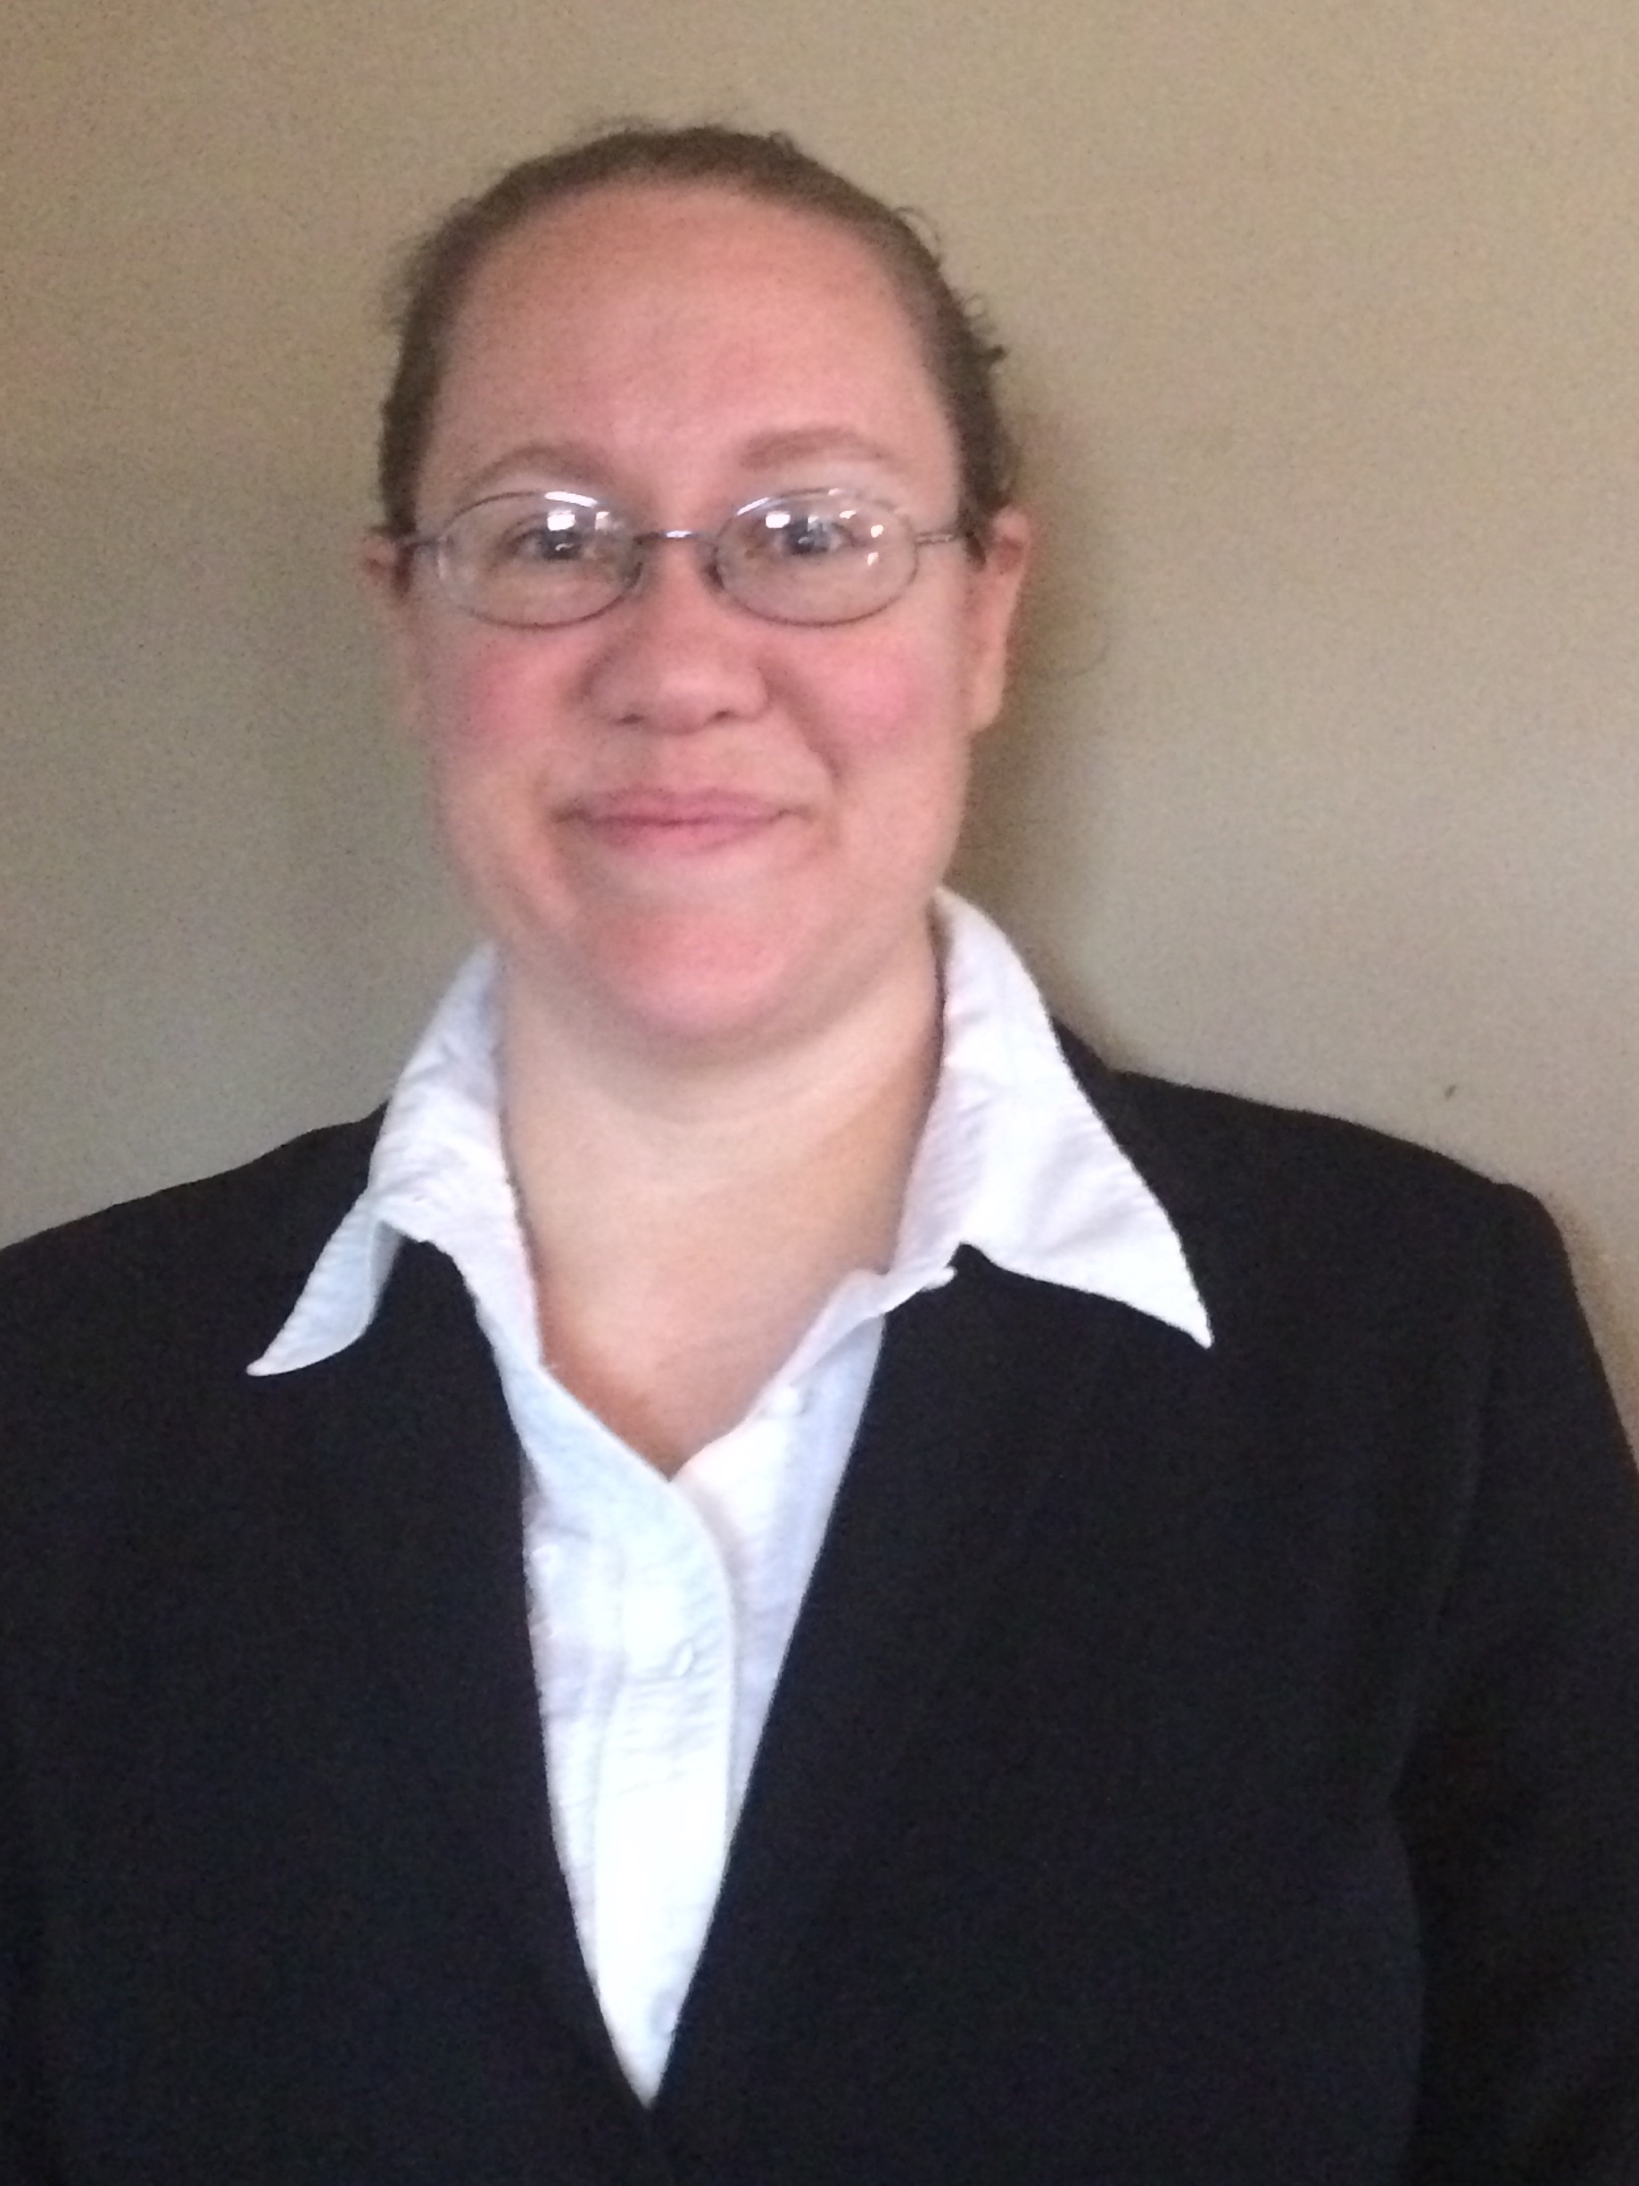 | Cynthia Vaughn  Ms. Vaughn is employed at the Tennessee Department of Revenue as a Certified Fraud Examiner. She has worked as an auditor and investigator with the State of Tennessee for more than 10 years. She completed a Graduate Certificate program in Forensic Document Examination at East Tennessee State University (ETSU). A student affiliate member of NADE, she is currently completing a mentorship training program in order to qualify for certification. She has a BS in Accounting from the University of Tennessee at Chattanooga (UTC), and completing studies towards an MCJ in Criminal Justice at Middle Tennessee State University (MTSU).  “Forensic Examination of Graffiti: Research and Challenges”  This presentation will discuss the challenges and limitations associated with the forensic identification of graffiti writers. Limitations in graffiti identification include quality of photographs submitted for examination, unusual media involved in the production of graffiti, awkward or unusual writing positions, literacy and graphic maturity, and assessment of class v. individual characteristics. We will review the current literature available on graffiti examination and discuss possible research that can improve forming conclusions in the forensic examination of graffiti.
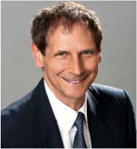 | Mike Wakshull, MSc., CQE  Mike Wakshull is a forensic document examiner based in Temecula, CA. In 1985 he founded Procyon Computer Systems, Inc., which developed and sold computer graphics software products in North America and Europe. He managed information systems governance at Amgen, the world’s largest biotechnology company. He holds a bachelor’s degree in mathematics, master’s degree in technology management, and a graduate school certificate in forensic document examination. Mike applies his background in science, information technology and mathematics to his forensic document examination work. This offers his clients a unique approach to their cases.  Mike is a member of NADE and vice president of Scientific Association of Forensic Examiners. He has presented at many international forensic conferences including in Chongqing, China and NIST. He is a member of National Speakers Association.  “Authentication of Digital Documents”  The days of examining documents by methods described by Osborn are gone. Well, maybe not completely gone. Yet as document examiners we receive documents in a form never conceived by Osborn, Harrison, Hilton, and others. We often receive documents in electronic form. These documents may have been created by digital microscope, word processing software, digital scanner, photocopy machine or other means.  As document examiners, we must keep up with technology to examine all types of documents. This presentation focuses on examination of electronic documents including e-mail, PDF, JPEG, TIFF, Microsoft Word®, digital camera images, and others. Methods of determining a whether document has been electronically altered are presented.
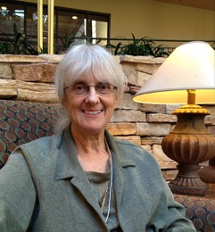 | Emily Will, D-BFDE, CDE  Emily Will has 28 years' experience as a private practice forensic document examiner located in Raleigh, North Carolina. Certified by NADE and the Board of Forensic Document Examiners (BFDE), she is currently the secretary of FSAB (Forensic Specialties Accreditation Board) and is a member of the NIST Expert Working Group on Human Factors in Handwriting Examination.  Emily’s favorite cases are the ones that include alterations or indented writing. When she is not examining documents, she is likely to be found in her fused glass workshop, cooking up something exotic in a glass kiln.  “Expressing Forensic Document Examination Opinions”  The language used by FDEs to express opinions is evolving. For the past 20 years the primary opinion scale used by practitioners has had 9 levels of opinion, with may examiners using only 7 or 5 of those levels. The strongest opinions were defined as “identification” and “elimination.” However in the years since 2009 and the publication of the NAS Report and the many investigations and reports related to forensic practice in the US and internationally, there are many voices endorsing a move away from the current scale to a propositional approach in which the emphasis is upon the evidence and which of the predefined propositions is supported by the evidence. This presentation will discuss this opinion terminology and demonstrate with case examples how it can be used and how it relates especially to the Modular Approach to Forensic Handwriting Examination.

